TEST PLAN

UNIT TESTING, TEST PLAN
- Standard Unit Testing Plan
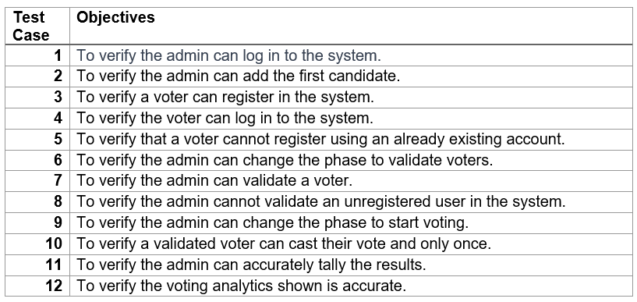
Table 2: Standard Unit Testing Plan

- Blockchain-Specific Unit Testing Plan
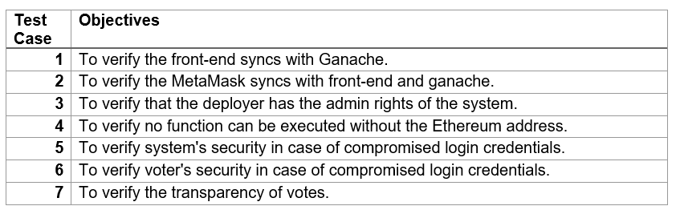
Table 3: Blockchain-Specific Unit Testing Plan

SYSTEM TESTING, TEST PLAN
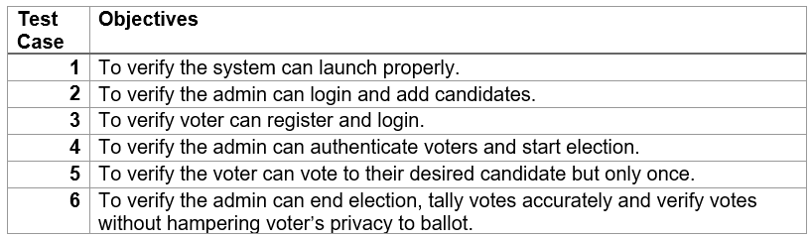
Table: System Testing, Test Plan

